SIMATS ENGINEERING (SAVEETHA SCHOOL OF ENGINEERING)
Department of Computer Science and Engineering
CO4 ASSESSMENT TOOL 2 – CI/CD Pipeline Design Exercise

Course Code: | CSA10 / CSA1063 | Course Title: | Software Engineering
CO Assessed: | CO4 | Assessment: | Assessment Tool 2 – CI/CD Pipeline Design Exercise
Weightage: | 20% | Total Marks: | 25
CO4 Statement: | Implement robust testing, quality assurance, and DevOps practices, emphasizing security, reliability, and ethics
Student Name: | S.PRATEEKSHA | Reg. No.: | 192572137
Date: | 21/8/26 | Duration: | 60 minutes

Code of Conduct
I S.PRATEEKSHA (Name / Reg No) certify that this submission is my original work and that I have adhered to the guidelines specified for this assessment. I understand that any violation of academic integrity rules will result in disciplinary action.
Signature of the Student:S.PRATEEKSHA
Annexure A – CI/CD Pipeline Design Exercise
Employee performance evaluations and productivity analytics system

Evaluation Criteria | Excellent (4 Marks) | Good (3 Marks) | Satisfactory (2 Marks) | Needs Improvement (1 Mark)
Requirement & Pipeline Analysis(15%) | Clearly analyzes the assigned problem and identifies comprehensive CI/CD requirements | Identifies most relevant requirements | Identifies basic requirements with some gaps | Requirements are unclear or incomplete
Pipeline Architecture & Workflow(25%) | Designs a complete, logical pipeline covering source, build, test, quality check, package, and deployment stages | Pipeline covers most major stages with minor gaps | Basic pipeline is designed but several stages are missing | Pipeline is incomplete or poorly structured
Tools & Technology Selection(20%) | Selects appropriate tools for each stage and provides clear justification | Appropriate tools selected with reasonable justification | Tools are identified but justification is limited | Tools are inappropriate or not clearly identified
Automated Testing & Quality Integration(15%) | Effectively integrates automated testing and code-quality/security checks into the pipeline | Includes major testing and quality checks | Includes basic testing with limited integration | Testing/quality checks are missing or inappropriate
Deployment, Security & Rollback Strategy(15%) | Clearly designs deployment environments, security practices, monitoring, and rollback strategy | Covers deployment and most security/rollback aspects | Basic deployment strategy with limited security/rollback details | Deployment strategy is incomplete or lacks security considerations
Pipeline Diagram & Documentation(10%) | Clear, accurate, professional diagram with excellent explanation and documentation | Well-presented diagram and documentation with minor issues | Adequate diagram/documentation but lacks clarity | Poorly presented, incomplete, or difficult to understand
Rubrics for Calculation

Criteria | Mark
Requirement & Pipeline Analysis(15%) | /5
Pipeline Architecture & Workflow(25%) | /4
Tools & Technology Selection(20%) | /4
Automated Testing & Quality Integration(15%) | /4
Deployment, Security & Rollback Strategy(15%) | /4
Pipeline Diagram & Documentation(10%) | /4
TOTAL | /25

Instructions to Students:
Each student is assigned an individual problem statement. Based on the assigned problem statement, design a CI/CD (Continuous Integration and Continuous Deployment) pipeline for the proposed software system to automate the processes of code integration, building, testing, and deployment.
The exercise should include:
- Analyze the project requirements and identify the CI/CD needs of the assigned problem statement.
- Design the CI/CD pipeline workflow showing stages such as source code management, build, testing, code quality analysis, packaging, and deployment.
- Identify suitable tools and technologies for each stage of the pipeline and justify their selection.
- Define appropriate automated testing strategies to be integrated into the pipeline.
- Design the deployment strategy, including development, testing/staging, and production environments.
- Incorporate appropriate security, quality checks, notifications, and rollback mechanisms in the pipeline.
- Prepare a CI/CD pipeline diagram and explain the workflow from code commit to deployment.
Deliverable: Submit a CI/CD Pipeline Design document containing the pipeline architecture/diagram, stages, tools, configuration/workflow, testing strategy, deployment process, and justification based on the assigned problem statement.
Answers:
1. Analyze the Project Requirements
1.1 Project Overview
The Employee Performance Evaluations and Productivity Analytics System is a web-based platform designed to help organizations evaluate employee performance, monitor productivity, collect feedback, and generate analytics.
The system consists of:
- Frontend: React + Vite
- Backend: Python Flask
- Database: PostgreSQL
- Analytics: Productivity and performance analytics module
- Containerization: Docker
- Version Control: Git + GitHub
- Deployment: Docker Compose
1.2 Why CI/CD is Required
A CI/CD pipeline is required to automatically verify, test, and deploy changes whenever developers update the system.
Without CI/CD:
Developer
↓
Write Code
↓
Manually Test
↓
Build
↓
Deploy
With CI/CD:
Developer
↓
Git Push
↓
Automatic Build
↓
Automated Testing
↓
Code Quality Check
↓
Security Scan
↓
Docker Build
↓
Staging Deployment
↓
Smoke Testing
↓
Production Deployment
↓
Monitoring

2. CI/CD Pipeline Workflow
The proposed pipeline contains the following stages:
Developer
↓
GitHub Repository
↓
Source Code Checkout
↓
Build
↓
Automated Testing
↓
Code Quality Analysis
↓
Docker Image Build
↓
Security Scan
↓
Staging Deployment
↓
Smoke Testing
↓
Production Deployment
↓
Monitoring
Pipeline Stages
Stage | Purpose
Source | Retrieve latest source code
Build | Install dependencies and build application
Test | Execute automated tests
Quality Check | Check code quality
Security Scan | Scan dependencies and Docker images
Package | Create Docker images
Staging | Deploy to test environment
Validation | Perform smoke tests
Production | Deploy validated version
Monitoring | Monitor application
Rollback | Restore previous version if deployment fails

3. Tools and Technologies
Pipeline Stage | Tool / Technology
Source Control | Git
Repository | GitHub
CI/CD | GitHub Actions
Frontend | React + Vite
Backend | Python + Flask
Database | PostgreSQL
Backend Testing | pytest
Frontend Testing | Vitest
Code Quality | ESLint
Containerization | Docker
Deployment | Docker Compose
Security | Dependabot / Trivy
Notifications | GitHub Actions
Why GitHub Actions?
GitHub Actions is suitable because the project source code is maintained in GitHub.
Therefore:
GitHub Repository
↓
GitHub Actions
↓
Build → Test → Scan → Deploy
No separate CI server is initially required.

4. Automated Testing Strategy
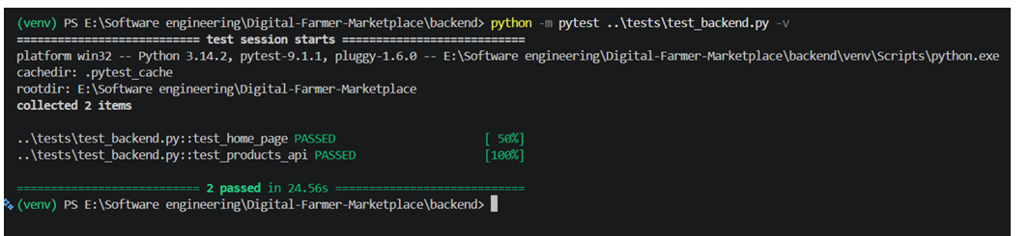
The pipeline should automatically test the application before deployment.
Testing is important because the system handles employee performance records, evaluation scores, productivity information, feedback, and analytics.
4.1 Backend Testing
Use pytest to test Flask APIs.
Example tests:
- Application starts successfully
- Employee API responds correctly
- Performance evaluation API responds correctly
- Productivity analytics API returns valid data
- Invalid API requests are handled
- Employee data validation works
- Role-based access is verified

Example:
def test_employee_api():
response = client.get("/api/employees")
assert response.status_code == 200
4.2 Frontend Testing
Automated frontend tests verify:
- Dashboard renders correctly
- Employee information loads
- Evaluation form works
- Productivity charts load
- Buttons work correctly
- Components render correctly
- Invalid input is handled
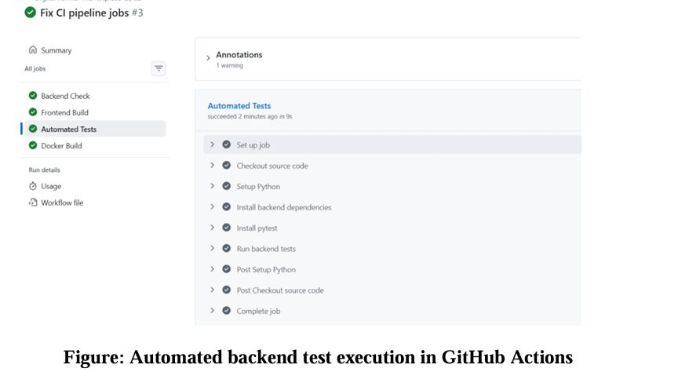
4.3 Integration Testing
Verify communication between:
React Frontend
↓
Flask API
↓
PostgreSQL Database
↓
Analytics Module
The pipeline should ensure that the frontend can communicate with the backend and that the backend can correctly retrieve employee performance and productivity data.
4.4 Smoke Testing
After deployment:
Application Opens
↓
Login Works?
↓
Dashboard Loads?
↓
Backend Responding?
↓
Employee Data Available?
↓
Analytics Available?
↓
PASS
If basic functionality fails, production deployment should be stopped or rolled back
5. Deployment Strategy
Use three environments.
Development
Used by developers during implementation.
Developer
↓
Feature Branch
↓
Development Environment
Staging
Used for final testing before production.
Development
↓
Automated Tests
↓
Staging
↓
Smoke Tests
Production
The final environment used by authorized HR personnel, managers, and administrators.
Staging
↓
Approval
↓
Production
Environment Flow
Feature Branch
↓
Development
↓
Testing
↓
Staging
↓
Validation
↓
Production

6. Security, Quality and Rollback
6.1 Security
The system should include:
- Employee authentication
- Role-based access control
- Dependency vulnerability scanning
- Docker image scanning
- Secure secret management
- Environment variables for sensitive information
- No passwords or API keys committed to GitHub
- HTTPS in production
- Access control for HR and managers
- Audit logging for important evaluation activities
Employee performance information should only be accessible to authorized users.
6.2 Quality Checks
Before deployment:
Code Checkout
↓
Linting
↓
Unit Tests
↓
Integration Tests
↓
Security Scan
↓
Docker Build
If any critical check fails:
Pipeline → FAILED
↓
Deployment STOPPED
7. Rollback Mechanism
If the new production version fails, the previous Docker image/version can be restored.
Example:
Version 1.0
↓
Production
↓
Version 1.1 Deployed
↓
Application Failure
↓
Rollback
↓
Version 1.0 Restored
This reduces downtime and allows the organization to continue using the previous stable version.

8. System Architecture Diagram
Employee / Manager / HR User
↓
React + Vite Web Interface
↓
Flask REST API
↓
Authentication & Role-Based Access
↓
PostgreSQL Database
↓
Performance & Productivity Analytics Engine
↓
Dashboards / Reports / Evaluation Insights
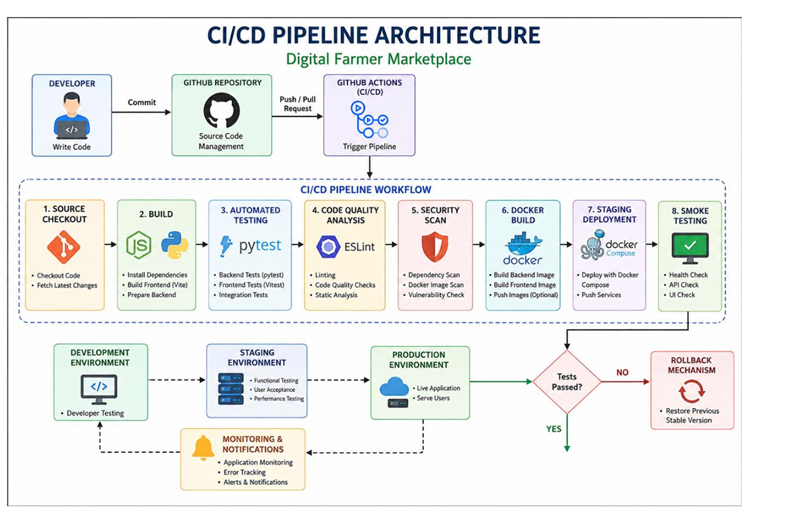
Main System Modules
- Employee Management Module
  - Employee profiles
  - Department information
  - Role management
- Performance Evaluation Module
  - Goal setting
  - Performance reviews
  - Manager evaluation
  - Feedback collection
  - Performance scores
- Productivity Analytics Module
  - Productivity metrics
  - Performance trends
  - KPI analysis
  - Department-level analytics
  - Employee performance reports
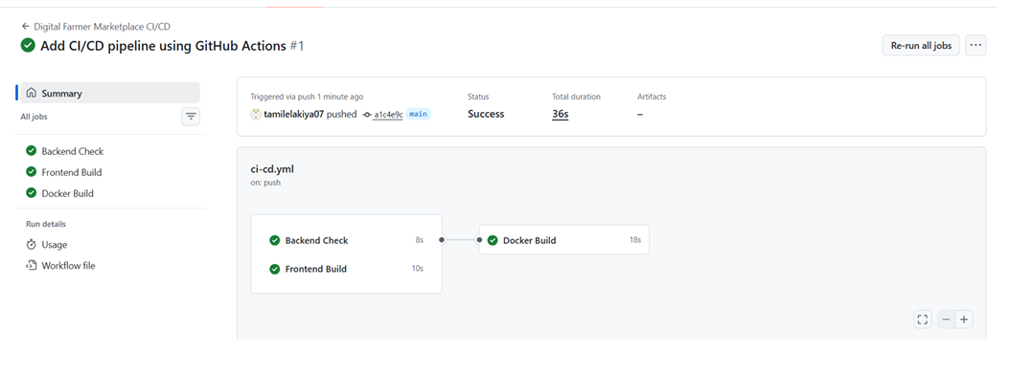
9. Employee Performance Evaluation Workflow
Employee Registration
↓
Performance Goals Set
↓
Employee Work Data Collected
↓
Manager Evaluation
↓
Peer / Feedback Collection
↓
Performance Score Calculation
↓
Productivity Analytics
↓
Dashboard Generation
↓
Performance Review
↓
Development Plan

10. Example GitHub Actions Workflow
For the actual project, create:
.github/
└── workflows/
└── ci-cd.yml
Basic pipeline:
name: Employee Performance Analytics CI/CD

on:
push:
branches: [main, development]

pull_request:
branches: [main, development]

jobs:

backend-test:
runs-on: ubuntu-latest

steps:
- name: Checkout source code
uses: actions/checkout@v4

- name: Setup Python
uses: actions/setup-python@v5
with:
python-version: "3.12"

- name: Install dependencies
working-directory: backend
run: pip install -r requirements.txt

- name: Run backend tests
working-directory: backend
run: pytest

frontend-build:
runs-on: ubuntu-latest

steps:
- name: Checkout source code
uses: actions/checkout@v4

- name: Setup Node.js
uses: actions/setup-node@v4
with:
node-version: "22"

- name: Install dependencies
working-directory: frontend
run: npm install

- name: Build frontend
working-directory: frontend
run: npm run build

docker-build:
needs:
- backend-test
- frontend-build

runs-on: ubuntu-latest

steps:
- name: Checkout source code
uses: actions/checkout@v4

- name: Build Docker images
run: docker compose build

11. Workflow Explanation
Step 1 — Code Commit
Developer modifies the project and pushes changes to GitHub.
Step 2 — Checkout
GitHub Actions retrieves the latest source code.
Step 3 — Build
Frontend dependencies are installed and the React/Vite application is built. Backend dependencies are installed using requirements.txt.
Step 4 — Testing
Automated tests verify:
- Backend APIs
- Evaluation functionality
- Productivity analytics
- Frontend components
- Data validation
Step 5 — Quality Analysis
Linting and code-quality checks identify coding issues.
Step 6 — Security
Dependencies and Docker images are checked for vulnerabilities.
Step 7 — Docker Packaging
Frontend and backend services are converted into Docker images.
Step 8 — Staging
The application is deployed using Docker Compose in the staging environment.
Step 9 — Smoke Testing
Basic application functions are verified.
Step 10 — Production
Only a successfully validated version is deployed.
Step 11 — Monitoring and Rollback
The application is monitored. If a critical failure occurs, the previous stable version is restored.

12. Justification
The proposed CI/CD approach is appropriate for the Employee Performance Evaluations and Productivity Analytics System because it integrates source control, automated testing, quality analysis, security scanning, containerized deployment, and monitoring.
React/Vite and Flask can be independently built and tested. PostgreSQL provides centralized storage for employee performance and productivity information. Docker provides a consistent execution environment, while Docker Compose simplifies deployment.
The pipeline improves:
- Development speed through automation
- Code quality through automated checks
- Reliability through testing
- Security through vulnerability scanning
- Deployment consistency through Docker
- Maintainability through structured workflows
- Rollback capability through versioned builds
- Decision-making through productivity analytics
- Collaboration through GitHub

13. Conclusion
The Employee Performance Evaluations and Productivity Analytics System provides an organized platform for managing employee evaluations, monitoring productivity, collecting feedback, and generating performance analytics.
Integrating CI/CD practices ensures that system changes are automatically built, tested, checked for quality, scanned for security vulnerabilities, deployed consistently, and monitored.
The proposed system improves reliability, security, maintainability, deployment efficiency, and data-driven employee performance management.

